CSA1715-ARTIFICIAL INTELLIGENCE
LAB PROGRAM-8
14-07-2026
8. Write the python program to implement DFS.

Aim
To write a Python program to implement the Depth-First Search (DFS) algorithm for graph traversal using user input.

Algorithm
- Read the number of vertices from the user.
- Read each vertex and its adjacent vertices to construct the graph as an adjacency list.
- Read the starting vertex for traversal.
- Initialize an empty visited set.
- Visit the starting vertex, display it, and mark it as visited.
- Recursively visit each unvisited adjacent vertex.
- Continue the traversal until all reachable vertices are visited.
- Terminate when no unvisited adjacent vertices remain.
Program
graph = {}

n = int(input("Enter number of vertices: "))

for i in range(n):
v = input("Enter vertex: ")
adj = input("Enter adjacent vertices (space separated): ").split()
graph[v] = adj

start = input("Enter starting vertex: ")

visited = set()

def dfs(node):
if node not in visited:
print(node, end=" ")
visited.add(node)
for i in graph[node]:
dfs(i)

print("DFS Traversal:")
dfs(start)

Input
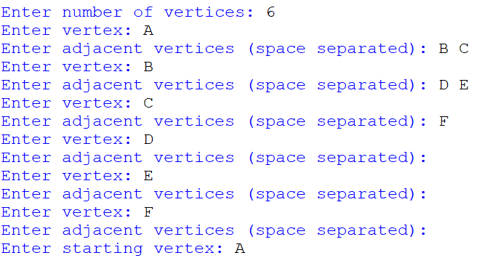
Output
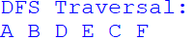
Result:
Thus, the Python program to implement the Depth-First Search (DFS) algorithm using user input was executed successfully, and the graph was traversed in DFS order with the desired output obtained.

